

PROPOSAL DOCUMENT

Outlook Exchange Setup

05 June 2025
© Sautech (Pty) Ltd. http://www.sautech.net

INTRODUCTION

The purpose of this document is to provide a complete step-by-step installation manual to configure your online hosted exchange profile. After all procedures in this document is followed completely, you will be able to connect to your new hosted exchange account using Microsoft Office 2007 sp3 and above.

Outlook setup

This procedure will help you configure your Microsoft outlook to be able to connect to the exchange server

🔹 Automatic Setup (Recommended for Microsoft 365)
- Open Outlook
- If it's your first time using Outlook, it will prompt you to Add an Account.
  - If not, go to:
  - Click on Start -> control panel (Details to set this up is below)
- Enter your Microsoft 365 email address (e.g., user@yourcompany.com)
- Click Connect
- Enter your password (and approve MFA if prompted)
- Click Finish – Outlook will configure everything automatically using Autodiscover

2.1.2 If not first time using outlook, following the following steps:

- Click on Start -> control panel, once opened , double click the “Mail” icon

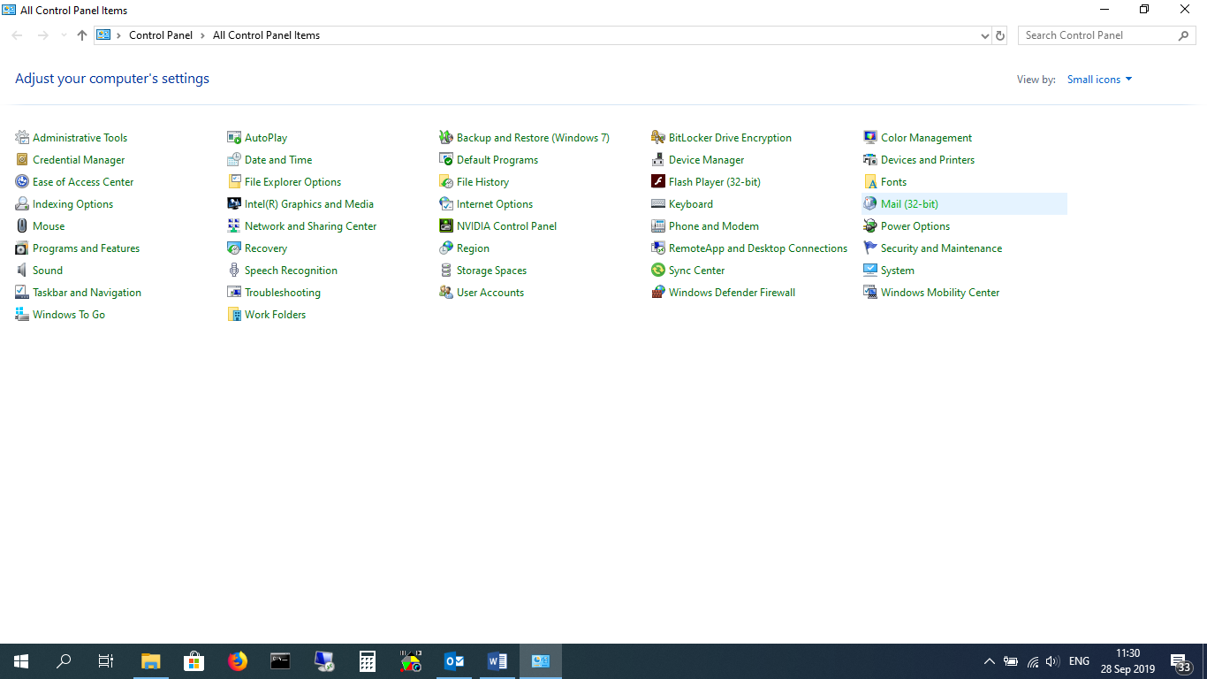

- Click on “Show Profiles”

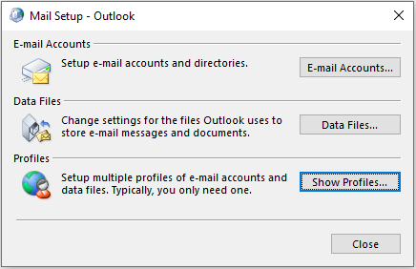

- Click on “Add”

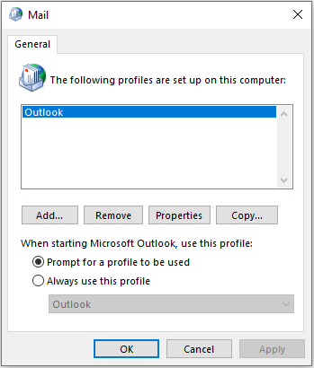

Make sure “prompt for a profile to be used” is selected (When we finish this process, and start outlook, you can select your old email or the newly created Exchange profile”

- Type a name in the profile window “example: New Exchange” and click on “ok”

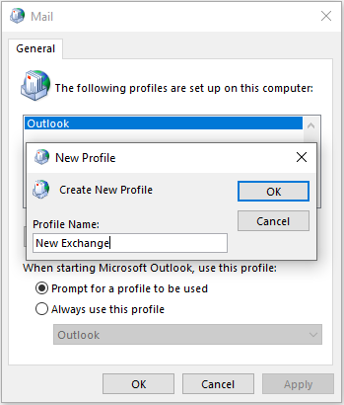

- Type Your Name,
Email Address, and email password x 2 – Click on Next

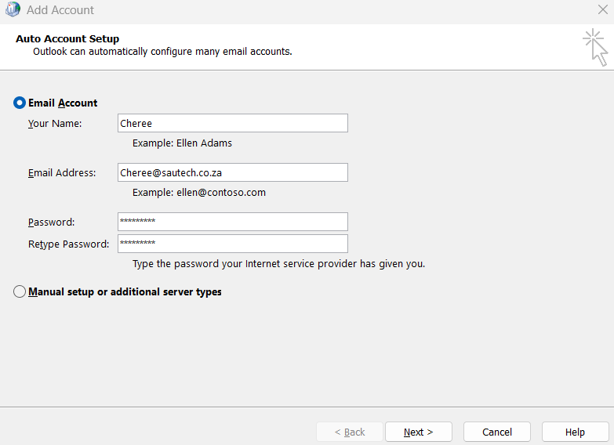

- Microsoft Pop up will appear. Enter email address (if needed) and password.
- Once done click on finish and mailbox will be setup.

